ENDOSCOPE IN NEUROSURGERY

Neuroendoscopy is a minimally-invasive surgical procedure in which the neurosurgeon removes the tumor through small holes (about the size of a dime) in the skull or through the mouth or nose.
Neuroendoscopy enables neurosurgeons to:
- Access areas of the brain that cannot be reached with traditional surgery
- Remove the tumor without cutting or harming other parts of the skull
The neuroendoscopy is performed using an endoscope, a small telescope-like device equipped with a high-resolution video camera and eye piece on the end to allow the neurosurgeon to navigate and access the tumor. Endoscope is an instrument used to examine the interior of a hollow organ or cavity of the body. Unlike most other medical imaging devices, endoscopes are inserted directly into the organ.
To remove a tumor or take a sample of it (a biopsy), neurosurgeons attach special instruments to the endoscope, often an additional endoscope with forceps and scissors on the end.
Images of the inside of the patient's body can be seen on a screen. The whole endoscopy is recorded so that doctors can check it again. Endoscopy is a minimally invasive diagnostic medical procedure. It is used to examine the interior surfaces of an organ or tissue.
Neuroendoscopy has a wide variety of uses in neurosurgery including biopsy or resection of certain types of tumors. Additionally, it can be used to fenestrate (create an opening in) cysts and other structures to allow drainage of fluid and relieve increased intracranial pressure or hydrocephalus.

HISTORY
The first endoscope was developed in 1806 by Philipp Bozzini in Mainz with his introduction of a "Lichtleiter" (light conductor) "for the examinations of the canals and cavities of the human body". However, the Vienna Medical Society disapproved of such curiosity. An endoscope was first introduced into a human in 1822 by William Beaumont, an army surgeon at Mackinac Island, Michigan. The use of electric light was a major step in the improvement of endoscopy. The first such lights were external. Later, smaller bulbs became available making internal light possible, for instance in a hysteroscope by Charles David in 1908. Hans Christian Jacobaeus has been given credit for early endoscopic explorations of the abdomen and the thorax with laparoscopy (1912) and thoracoscopy (1910). Laparoscopy was used in the diagnosis of liver and gallbladder disease by Heinz Kalk in the 1930s. Hope reported in 1937 on the use of laparoscopy to diagnose ectopic pregnancy. In 1944, Raoul Palmer placed his patients in the Trendelenburg position after gaseous distention of the abdomen and thus was able to reliably perform gynecologic laparoscopy.

Wolf and Storz
Georg Wolf, a Berlin manufacturer of rigid endoscopes, established in 1906, produced the Sussmann flexible gastroscope in 1911. Karl Storz began producing instruments for ENT specialists in 1945. His intention was to develop instruments which would enable the practitioner to look inside the human body. The technology available at the end of the Second World War was still very modest: The area under examination in the interior of the human body was illuminated with miniature electric lamps; alternatively, attempts were made to reflect light from an external source into the body through the endoscopic tube. Karl Storz pursued a plan: He set out to introduce very bright, but cold light into the body cavities through the instrument, thus providing excellent visibility while at the same time allowing objective documentation by means of image transmission. With more than 400 patents and operative samples to his name, Karl Storz played a crucial role in the development of endoscopy. It was however, the combination of his engineering skills and vision, coupled with the work of optical designer Harold Hopkins that ultimately would revolutionize the field of medical optics.

Use of fiber optics
Fernando Alves Martins of Portugal invented the first fiber optic endoscope in 1963-64. Earlier in the 1950s Harold Hopkins had designed a “fiberscope” consisting of a bundle of flexible glass fibers able to coherently transmit an image. This proved useful both medically and industrially, and subsequent research led to further improvements in image quality. Further innovations included using additional fibers to channel light to the objective end from a powerful external source, thereby achieving the high level of full spectrum illumination that was needed for detailed viewing, and color photography. The previous practice of a small filament lamp on the tip of the endoscope had left the choice of either viewing in a dim red light or increasing the light output - which carried the risk of burning the inside of the patient. Alongside the advances to the optical side, the ability to 'steer' the tip was developed, as well as innovations in remotely operated surgical instruments contained within the body of the endoscope itself. This was the beginning of "key-hole surgery" as we know it today.

Rod-lens endoscopes
However, there were physical limits to the image quality of a fibroscope. In modern terminology, a bundle of say 50,000 fibers gives effectively only a 50,000 pixel image - in addition to which, the continued flexing in use, breaks fibers and so progressively loses pixels. Eventually so many are lost that the whole bundle must be replaced (at considerable expense). Hopkins realized that any further optical improvement would require a different approach. Previous rigid endoscopes suffered from very low light transmittance and extremely poor image quality. The surgical requirement of passing surgical tools as well as the illumination system actually within the endoscope's tube - which itself is limited in dimensions by the human body - left very little room for the imaging optics. The tiny lenses of a conventional system required supporting rings that would obscure the bulk of the lens area; they were extremely hard to manufacture and assemble and optically nearly useless. The elegant solution that Hopkins produced (in the late 1960s) was to fill the air-spaces between the 'little lenses' with rods of glass. These fitted exactly the endoscope's tube - making them self-aligning and requiring of no other support and allowed the little lenses to be dispensed with altogether. The rod-lenses were much easier to handle and utilized the maximum possible diameter available. With the appropriate curvature and coatings to the rod ends and optimal choices of glass-types, all calculated and specified by Hopkins, the image quality was transformed - even with tubes of only 1mm. in diameter. With a high quality 'telescope' of such small diameter, the tools and illumination system could be comfortably housed within an outer tube. Once again, it was Karl Storz who produced the first of these new endoscopes as part of a long and productive partnership between the two men. Whilst there are regions of the body that will forever require flexible endoscopes (principally the gastrointestinal tract), the rigid rod-lens endoscopes have such exceptional performance that they are to this day the instrument of choice and in reality have been the enabling factor in modern key-hole surgery. (Harold Hopkins was recognized and honored for his advancement of medical-optic by the medical community worldwide. It formed a major part of the citation when he was awarded the Rumford Medal by the Royal Society in 1984.)

COMPONENTS OF ENDOSCOPE
The essential components of an endoscope are:
- A rigid or flexible tube – depending on whether the Endoscope is Rigid Endoscope or Flexible Endoscope
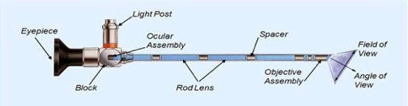
Rigid tube
- Light delivery system to illuminate the organ or object under inspection. The light source is normally outside the body and the light is typically directed via an optical fiber system.
- Objective lens turns the incident light into an image, projecting it onto the following component. It comprises 2 to max. 9 lenses as well as a prism if different viewing directions are required (Swing Prism Endoscope).
- Relay System transmitting the image from the objective lens to the viewer, typically a Rod- relay lens system in the case of rigid endoscopes or a bundle of fiber optics in the case of a fiberscope.
- Eyepiece lens - The eyepiece lens magnifies the image transmitted by the rod lenses or image guides virtually, giving the viewer the impression of a large image circle.

Components of Endoscope

- additional channel(s) to allow entry of medical instruments or manipulators

PRINCIPLE
The basic principles underlying the use of endoscopes involve the science of optics. Light is used to illuminate the object to be viewed, thus allowing it to be seen and interpreted by the human brain. Optical lenses (or Optical Fibers) are used to manipulate the returning light in order to produce an enhanced and clearly focused image of that object.

Illumination is based on Total Internal Reflection
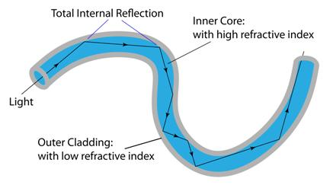
Total Internal Reflection

Conditions for TIR to occur:
- Refractive Index of the core must be greater (1.62 generally) than that of the cladding (1.52 generally) i.e. TIR occurs when light travels from a medium with high RI to the one with lower RI.
- Light entering the Fiber must have an angle greater than the Critical Angle
- Light rays within the Acceptance Cone only can enter the fibers to undergo TIR
Manipulation of returning light is based on:
- Relay System in case of Rigid Endoscopes
- TIR in case of Flexible Endoscopes

TYPES
Depending on the type of light transmission, endoscopes are categorized as:
- Flexible Endoscope
- Rigid Endoscope
In addition to the actual endoscope, light source, cameras and monitor for viewing while the procedure is performed, instruments for use with endoscope, and a number of holding devices to immobilize the endoscope are the integral parts of the system.
FLEXIBLE/ STEERABLE ENDOSCOPE
Also called as Ventriculoscopes

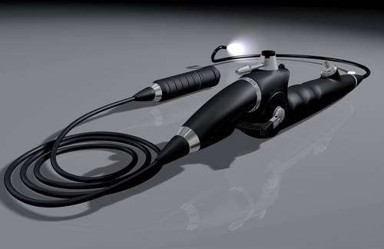
Flexible Endoscope

Flexible Endoscope is comprised of a number of glass fibers that are incorporated into a plastic sheath. The size of the fiber bundle determines the resolution of images. They are fitted with at least one working channel which can also serve as a site for fluid egress and irrigation throughout the procedure. Working instruments consisting of biopsy forceps, graspers and scissors are available and they are also flexible in their design and construction. They range in size from 1-15mm in outer diameter depending on the number of fibers within them.

PRINCIPLE
- Rely on fiber optic illumination. The optical system used in this type of endoscope consists of fiber glass bundles. It allows a better overview of areas that are otherwise difficult to access, and offers improved brightness.
Fiber Optical Bundles work on the principle of Total Internal Reflection where 100% of the light that was transmitted from the source to the organs reflects back.

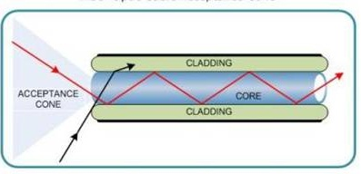
Light within acceptance cone only can enter the optical fiber to undergo TIR

Acceptance Cone- It is the range of angles over which light rays can enter the fiber and be trapped in its core
Only light that enters the fiber within a certain range of angles known as the Acceptance cone can be successfully propagated the length of the fiber without leaking out
Size of Acceptance cone is a measure of the Refractive Index differences between the fibre’s core and its cladding layer.
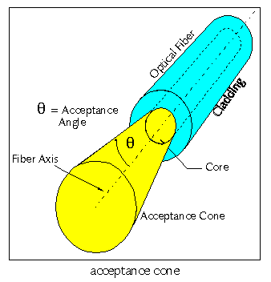
CONSTRUCTION
They have two bundles of fibers:
- An outer ring of incoherent fibers that supplies the light to the internal organs
- An inner coherent bundle that receives the light and transmits all the rays of light to the eye of the examiner - Image Guide
The fibers are made up of a special type of glass and each of them is coated with another glass of different refractive index. Special attention is given to the orientation of the fibers with one another in the bundle so that they are ‘coherent’. For an endoscope the ‘spatial orientation’ among each of the thousand fibers should be equal and not like the fibers that are tangled with one another in a rope.
Flexible endoscopes consist of an elongate plastic-coated endoscope sheath containing optical components such as the objective lens and the image guide as well as the light-transmitting glass fibers.
Flexible endoscopes are also equipped with additional separate channels for suction and irrigation fluid supply and/or for instrument passage.
Flexible endoscopes with image guide technology comprise three different assemblies that form the optical system
- Objective lens
- Image guide - a precisely arranged glass fiber bundle for transmitting the image
- Ocular lens
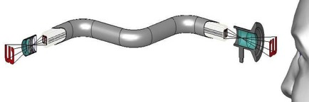
Formation of image using glass fiber bundles
The objective lens projects the object onto a thin bundle of precisely arranged glass fibers. The individual fibers have typical diameters between 4 µm and 14 µm. Between 3,000 and 50,000 fibers are used depending on the diameter and field of use.

The image guide transmits the virtual image of the objective lens optically to the ocular lens (eyepiece) of the flexible endoscope,

Ocular lens/ Eyepiece magnify the image so as to make it visible to the viewer.
ADVANTAGE
They can be used to navigate in the ventricular system and around corners when used as an assist-device during microsurgical operations.

DISADVANTAGES
- Optics are worse than those of rigid endoscopes
- Cannot be autoclaved and must be gas-sterilized, which limits their longevity
- Frequent use can damage the fiber bundle, which further decreases the image resolution

RIGID ENDOSCOPE
(Most frequently utilized endoscope in Neurosurgery)
Rigid endoscopes consist of a long cladding tube (endoscope sheath) within which the optical components such as prisms and lenses are aligned to form a lens system. The sheath also contains a separate channel made of glass fibers for transmitting light (based on TIR). There may be more channels, e.g. for suction and irrigation fluid and/or instruments.

PRINCIPLE- based on Relay Lens System
Relay lens is a lens or lens group that inverts an image and extends the optical tube. Relay lenses are found in endoscopes for the purpose of extending the system, and before eyepieces for the purpose of inverting an image.

Rigid Endoscopes use one of the three technologies to relay the images
- Achromatic doublets, which are cost effective in large-diameter endoscopes.
- Hopkins design relays, which give excellent quality for medium diameters but require precise grinding, polishing and centering of many tiny lenses and optical glass rods.
- Gradient index of refraction (GRIN) lenses, which afford the best combination of quality and price for medium and small-diameter endoscopes, because the relay optics are simple, chemically treated glass rods. One gradient index rod, for example, can replace 24 optical elements in a Hopkins design scope.
- Achromatic Doublets
An achromatic lens or achromat is a lens that is designed to limit the effects of chromatic and spherical aberration. Achromatic lenses are corrected to bring two wavelengths (typically red and blue) into focus in the same plane.
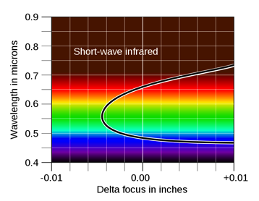
In an achromatic lens, two wavelengths are brought into the same focus, here red and blue

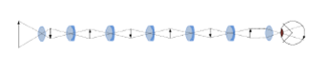
Image Formation using Achromatic Doublets

The most common type of achromat is the achromatic doublet, which is composed of two individual lenses made from glasses with different amounts of dispersion. Typically, one element is a negative (concave) element made out of flint glass such as F2, which has relatively high dispersion, and the other is a positive (convex) element made of crown glass such as BK7, which has lower dispersion. The lens elements are mounted next to each other, often cemented together, and shaped so that the chromatic aberration of one is counterbalanced by that of the other.
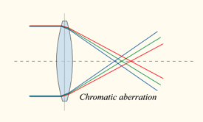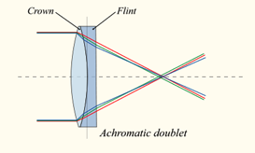

Types of Achromatic Doublets-

In the most common type, the positive power of the crown lens element is not quite equaled by the negative power of the flint lens element. Together they form a weak positive lens that will bring two different wavelengths of light to a common focus. Negative doublets, in which the negative-power element predominates, are also made.

- Rod lenses
The rod lens system was developed by Hopkins and therefore referred to as the Hopkins System.
The reversal system consists of a series of rod lenses (relay lenses). They serve to transmit the image within the endoscope. Rod lenses made of glass provide a clearly higher light transmission efficiency compared to conventional lenses where the area filled with air between the lenses is relatively large.
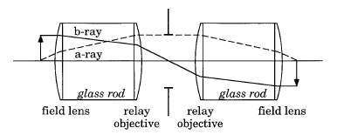
One stage of Hopkins Rod Lens
Three stages of Rod Lens- image Reversal Occurs after every stage
In practice, the lens will be an achromatic doublet. Also, for endoscope applications, where small tube diameter is desirable, most of the tube is filled with glass, with thin air gaps to allow for powered surfaces; because marginal ray angle is smaller at a given numerical aperture the higher the index of refraction, this allows the relay to have higher NA for a given diameter.

- GRIN lens
Gradient-index (GRIN) optics is the branch of optics covering optical effects produced by a gradual variation of the refractive index of a material. Such variations can be used to produce lenses with flat surfaces, or lenses that do not have the aberrations typical of traditional spherical lenses. Gradient-index lenses may have a refraction gradient that is spherical, axial, or radial.
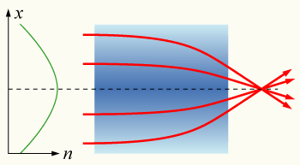
GRIN Lens with parabolic variation in refractive index (n) with radial distance (x)
GRIN (Gradient Index) Relay System v/s Hopkins Relay system

GRIN Relay System v/s Hopkins Relay System
- GRIN Relay use flat ends glass rod
- GRIN Relay use much less components and is therefore cheaper

CONSTRUCTION- In rigid endoscopes the optical system consists of a series of prisms and lenses. The main components are:
- Objective / lens - for image formation
- Rod lens system – transmission System- for image transport – Reversal System
- Ocular lens - for image magnification

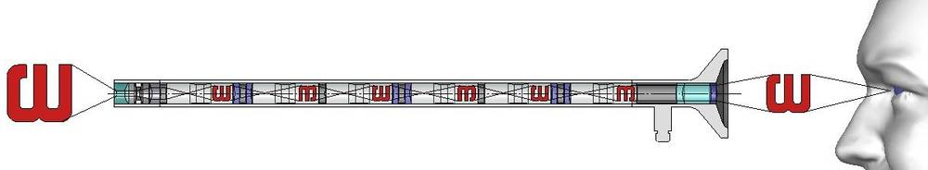
Formation of Image using Rod Lens System

Objective Lens
The objective lens is required to reproduce the image inside the endoscope. It is located at the distal tip of the endoscope. The objective lens can be composed of up to 9 individual lenses. All angled directions of view such as 5°, 12°, 30°, 50° 70°, etc. require a prism with the corresponding angle as the first component of the objective lens. Endoscopes with an angle of view of 0° (or any fixed angle) do not need a prism.
Relay System
The Relay System transfer the image from the objective to the eyepiece
Eyepiece
The ocular lens or eyepiece serves to magnify the virtual image thus allowing image focus adjustment. The object distance can be changed depending on the application.

DESIGN OF RIGID ENDOSCOPE- there are two main designs:
- A sheath with a single channel for the endoscope – This Endoscope is used just for inspection during Microsurgical Procedures, to view if the tumor/ lesion has been completely removed or not as it allows the surgeon to look behind the corners unlike Microscope

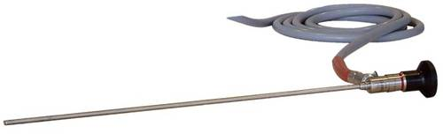
Rigid Endoscope

- An endoscopic sheath with multiple separate channels for the instruments in addition to lens and light fiber – this Endoscope is used to insert the surgical instruments through the channels provided in the Endoscope to perform the surgical procedures. These are actually the operating Endoscopes.

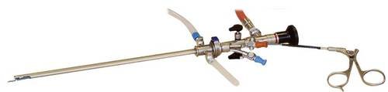
Rigid Operating Endoscope with a single instrumentation Channel

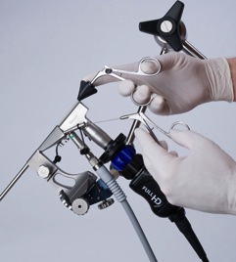
Operating Endoscope with two working channels

ADVANTAGES
- Superior optics
- Autoclavable, reusable
- Less fragile
DISADVANTAGES-
- Rigidity- one cannot maneuver them in the intraventricular or intracranial spaces as freely as flexible endoscopes
It is crucial to plan the entry burr hole in such a location as to allow for the greatest freedom of movement without endangering any neurovascular structures
Neuroendoscopes, in general do not exceed diameters of 8 mm. The thinnest endoscopes used for example in pediatrics, measure only 1.9 mm in diameter. Depending on its use and medical discipline, an endoscope may be between 4 cm and 200 cm long.

IRRIGATION
Visualization with an endoscope requires fluid filled spaces; any bleeding or spillage of tumor or cyst content may obscure the view. Therefore, irrigation is very important for clearing of CSF Spaces and can also be used to dilate the ventricular spaces so as to allow more movement of the endoscope within them.
Irrigation can be performed continuously or via pulsed/ bolus injection throughout the procedure. This is the most useful maneuver if bleeding is encountered during endoscopy; usually irrigation is continues until the bleeding is stopped and the CSF is clear. The solution utilized can be either lactated Ringer Solution or normal saline.
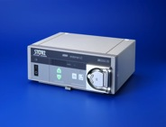
Used with Adapter for irrigation
It is important to monitor the amount of fluid injected/irrigated and the amount of fluid that has drained out so as to avoid a potential increase in ICP or pressure on the floor of the third ventricle. In addition, continuous confirmation of the anatomy and the position by visualization of the endoscope and the landmarks can be accomplished in this manner and can avoid potentially serious complications.

LIGHT SOURCE
All endoscopes require a light source and these are universally available but require filters to avoid the hot IR spectrum
The light source is connected to the endoscope via a flexible, fiber-optic cable. The efficiency of light transmission is reduced as the cable length increases.

There are two major types of light source available:
- TUNGSTEN-HALOGEN LIGHT SOURCE-
Works on the Principle of Incandescence where electricity produces light with filament wire heated to a high temperature (white hot) by an electric current passing through it until it glows.
They are thermal Radiators i.e. they produce light by heating a solid body to a high temperature.

Construction
It has a tungsten filament and a small amount of Halogen such as Iodine or Bromine. The hot filament is protected from oxidation with a glass bulb that is filled with an inert gas.
Operation
When power is supplied to the bulb, the tungsten filament gas heated up and light is produced when it becomes white hot. Tungsten starts evaporating off the filament like a normal bulb. Halogen present inside the tube combines with the evaporating tungsten to produce a Halogen Cycle Chemical Reaction to redeposit the evaporated tungsten back on the filament increasing its life and maintaining the clarity of the envelope. Because of this, a halogen lamp can be operated at a higher temperature than a standard gas-filled lamp of similar power and operating life, producing light of a higher luminous efficacy and color temperature.
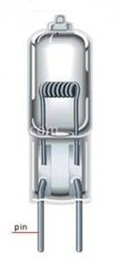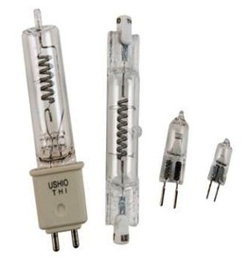
Halogen Lamps

They use a special infrared coating to redirect infrared light back toward the tungsten filament, reducing waste heat and improving efficiency by up to 30 percent over typical incandescent bulbs
Halogen Bulbs keep a constant light output throughout their lives.

Halogen Lamps v/s Standard Incandescent Lamps
- Tungsten halogen lamps are a refinement of incandescent technology that offer up to 20 percent greater energy efficiency, longer service life and improved light quality. In a standard incandescent lamp, tungsten from the filament evaporates over time and is deposited on the walls of the bulb, thus reducing light output. The filament gets thinner and thinner and eventually breaks, causing the lamp to fail. The halogen gas inside a halogen lamp causes the evaporated tungsten to redeposit on the filament. This process, along with high pressure inside the capsule, slows down deterioration of the filament, improves lumen maintenance and extends the lamp’s service life.
- Whiter, Brighter Light- Halogen lamps have higher colour temperatures than standard incandescent lamps—their light output contains more blue and green. Halogen lamps therefore appear whiter and brighter.

- XENON LIGHT SOURCE- use HID (High Intensity Discharge) Technology
A xenon arc lamp is a specialized type of gas discharge lamp, an electric light that produces light by passing electricity through ionized xenon gas at high pressure. It produces a bright white light that closely mimics natural sunlight
Principle
HID is a type of Gas-Discharge which produces light by means of an electric arc between tungsten electrodes housed inside a translucent or transparent fused quartz or fused alumina arc tube. This tube is filled with both gas and metal salts. The gas facilitates the arc's initial strike. Once the arc is started, it heats and evaporates the metal salts forming a plasma, which greatly increases the intensity of light produced by the arc and reduces its power consumption. High-intensity discharge lamps are a type of arc lamp.
High-intensity discharge lamps make more visible light per unit of electric power consumed than fluorescent and incandescent lamps since a greater proportion of their radiation is visible light in contrast to heat.

Lamp construction
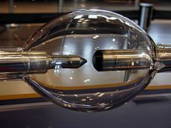

Xenon Arc Lamp
All modern xenon short-arc lamps use a fused quartz envelope with thoriated tungsten electrodes. Fused quartz is the only economically feasible material currently available that can withstand the high pressure and high temperature present in an operating lamp, while still being optically clear. The thorium dopant in the electrodes greatly enhances their electron emission characteristics. Because tungsten and quartz have different coefficients of thermal expansion, the tungsten electrodes are welded to strips of pure molybdenum metal or Invar alloy, which are then melted into the quartz to form the envelope seal.

Light generation mechanism

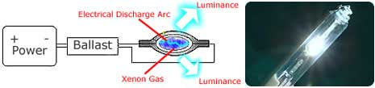

Light Generation in a Xenon Bulb
In operation the gas is ionized, and free electrons, accelerated by the electrical field in the tube, collide with gas and metal atoms. Some electrons in the atomic orbital of these atoms are excited by these collisions to a higher energy state. When the excited atom falls back to a lower energy state, it emits a photon of a characteristic energy, resulting in infrared, visible light, or ultraviolet radiation.

Types of Xenon Arc Lamps

Continuous output Xenon Short-arc Lamps

Continuous Output Xenon Long Arc Lamps

Xenon Flash Lamps

Continuous output Xenon short arc lamp is used as a light source in the Endoscope. Xenon short-arc lamps come in two distinct varieties:
- Pure xenon, which contain only xenon gas;
- Xenon-mercury, which contain xenon gas and a small amount of mercury metal.
In a pure xenon lamp, the majority of the light is generated within a tiny, pinpoint-sized cloud of plasma situated where the electron stream leaves the face of the cathode. The light generation volume is cone-shaped, and the luminous intensity falls off exponentially moving from cathode to anode. Electrons passing through the plasma cloud strike the anode, causing it to heat. As a result, the anode in a xenon short-arc lamp either has to be much larger than the cathode to dissipate the heat.
In xenon-mercury short-arc lamps, the majority of the light is generated in a pinpoint-sized cloud of plasma situated at the tip of each electrode. The light generation volume is shaped like two intersecting cones, and the luminous intensity falls off exponentially moving towards the centre of the lamp. Xenon-mercury short-arc lamps have a bluish-white spectrum and extremely high UV output.
Disadvantage
- All xenon short-arc lamps generate substantial ultraviolet radiation. Xenon has strong spectral lines in the UV bands, and these readily pass through the fused quartz lamp envelope. Unlike the borosilicate glass used in standard lamps, fused quartz does not attenuate UV radiation unless it is specially doped. The UV radiation released by a short-arc lamp can cause a secondary problem of ozone generation. The UV radiation strikes oxygen molecules in the air surrounding the lamp, causing them to ionize. Some of the ionized molecules then recombine as O₃, ozone. Equipment that uses short-arc lamps as the light source must contain UV radiation and prevent ozone build-up.
Many lamps have a low-UV blocking coating on the envelope and are sold as "Ozone Free" lamps. Some lamps have envelopes made out of ultra-pure synthetic fused silica (such as "Suprasil"), which roughly doubles the cost, but which allows them to emit useful light into the vacuum UV region. These lamps are normally operated in a pure nitrogen atmosphere.
- HID Lamps are more complicated to manufacture, and they require auxiliary electronic equipment such as ballasts to control current flow through the gas.

Ceramic Xenon lamps
Xenon short-arc lamps also are manufactured with a ceramic body and an integral reflector. They are available in many output power ratings with either UV transmitting or blocking windows. The reflector options are parabolic (for collimated light) or elliptical (for focused light). These are used in Endoscopes.

XBO Lamps
XBO lamps are short arc lamps in which the discharge arc fires in a pure xenon atmosphere under high pressure. XBO lamps have a very good color rendering and extremely high luminance. For this reason they are often used in light guide systems, e.g., for endoscopy.

HALOGEN LIGHT SOURCE v/s XENON LIGHT SOURCE
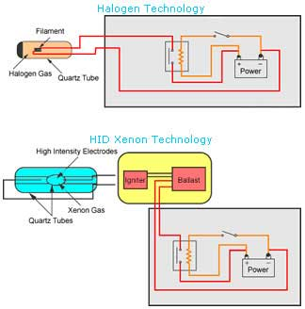
Halogen Light Source v/s Xenon light Source

- Line voltage (120 volts) xenon lamps operate especially cooler than line voltage halogen lamps, which can become extremely hot
- Xenon lamps produce more light for a given level of power consumption than tungsten-halogen bulbs
- Xenon Bulb last 2-3 times longer as Halogen Bulb still uses filament that will eventually burn out
- Xenon Lamp produce brighter light
- Xenon Bulbs use less energy
- Light output from a 35W Xenon lamp is 300% more Visible Light than in a 55W halogen bulb
- Xenon Source provides more uniform intensity in lighting
- Xenon lamp consume much less power & generate much less heat
- Xenon source provides increased contrast and color vision

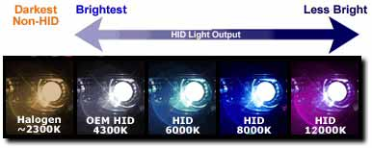
Color Temperature of Halogen and HID Xenon Light source
Color Temperature is the measurement in Degrees Kelvin that indicates the hue of light Source.
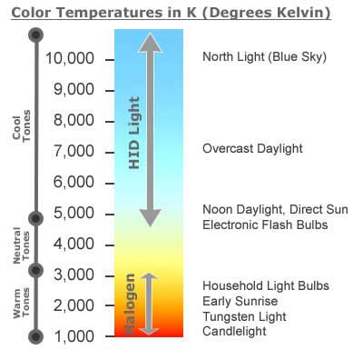
CAMERA
Observation of the procedure requires a camera, monitor, and video system, which often incorporated recording systems.
Endoscopy cameras attach to the eye-piece and greatly improve endoscopic ability
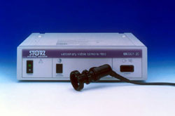
Basic camera with a focusing ring
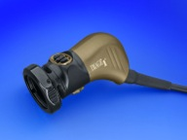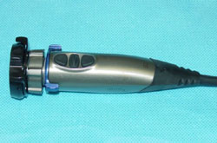
Advanced models with focus and zoom functions, and a variety of other digital features like White Balance

The cameras require gas sterilization and therefore can be either sterile or draped in a special plastic sheath so that their longevity is increased.

TYPES OF CAMERA
- One Chip Camera- One chip camera uses a single chip to process the colors the computer sees. The chip detects only one third of the color information for each pixel, rest two-thirds is interpolated using some algorithm (Demosaicing) to fill in the gaps resulting in much lower effective Resolution

- Three Chip Camera- Three-Chip Camera is a camera whose imaging system uses three separate chips, each one taking a separate measurement of the primary colors, red, green, or blue light. Light coming into the lens is split by a trichroic prism assembly, which directs the appropriate wavelength ranges of light to their respective chips.
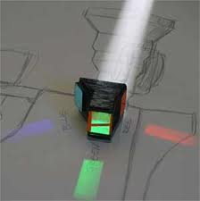
A color separation beam splitter prism assembly with a white beam entering the front, and the red, green and blue beams exiting the three focal plane faces

Trichroic Prism Assembly is a combination of two dichroic prisms. A Dichroic Prism is a prism that splits light into two beams of different wavelengths (colors). Certain surfaces within the prism acts as Dichroic Filters (very accurate color filter used to selectively pass light of a small range of colors while reflecting other colors. Also called as Dichroic Mirrors and Dichroic Reflectors. They are characterized by the colors of light they reflect rather than the colors they pass). These are used as beam splitters.

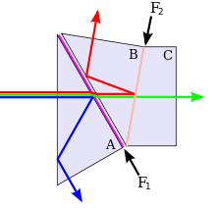
Trichroic Prism Assembly

Working-

A light beam enters the first prism (A) and the blue component of the beam is reflected from a Low-Pass Filter coating (F₁) that reflects blue light (high-frequency), but transmits longer wavelengths (lower frequencies). The blue beam undergoes total internal reflection from the front of prism A and exits it through a side face. The remainder of the beam enters the second prism (B) and is split by a second High-Pass Filter coating (F₂) that reflects red light (low-frequency) but transmits shorter wavelengths (higher frequencies). The red beam is also totally internally reflected due to a small air-gap between prisms A and B. The remaining green component of the beam travels through C.
The trichroic prism assembly can be used in reverse to combine red, green and blue beams into a coloured image, and is used in this way in some projector devices. Assemblies with more than 3 beams are possible.

THREE CHIP v/s ONE CHIP CAMERA
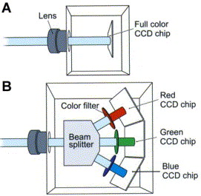
- Separate readings of Red, Green and Blue values for each pixel
- Enhanced Resolution
- Reduce Video Noise
- Improve SNR(Signal-to-noise Ratio)
- Better precision
- High cost
- Detect only one-third of the color information for each pixel
- Much lower effective Resolution
- Low cost
- Single Chip Camera B. Three Chip Camera

Compared to cameras with only one CCD, three-CCD cameras generally provide superior image quality through enhanced resolution and lower noise. By taking separate readings of red, green, and blue values for each pixel, three-Chip cameras achieve much better precision than single-Chip cameras. By contrast, almost all single-CCD cameras use a Bayer filter, which allows them to detect only one-third of the color information for each pixel. The other two-thirds must be interpolated with a demosaicing algorithm to 'fill in the gaps', resulting in a much lower effective resolution.
RECORDING
The procedures can be recorded with some of the newer digital imaging technology available for neurological procedures, as well as with VHS tapes; recording is advisable with most procedures.
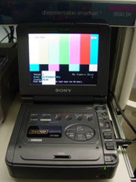
Recording in Hard Disk

Documentation of all endoscopic procedures is preferable and should be performed either on VHS tapes or digitally, as with the newer imaging technologies.

MONITORS
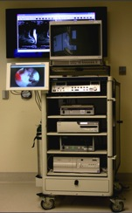
Trolley with Two monitors – one for the surgeon and assistant surgeon, and second for the other OR personnel

Monitors need to be positioned so that the surgeon, the assistant and the operating room personnel can all view them.
PLANNING THE NEUROENDOSCOPIC APPROACH
- Stereotactic Neurosurgical Technique
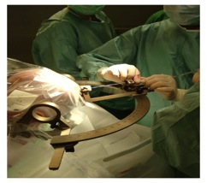
Attachment of Stereotactic Head Frame
Uses the concept of coordinate geometry
Brain is assumed to be spherical and using the three coordinates, X, Y & Z axes, lesions inside the brain can be targeted.

- Neuronavigation

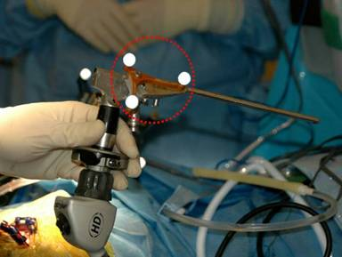

Marker with retro-reflective spheres is attached to the endoscope to track the exact location of the surgical instruments used with the endoscope

This technique is advantageous over Stereotactic Neurosurgical technique because the surgeon has greater degree of freedom in the manipulation of the endoscope when it does not need to be attached to the stereotactic frame.
PROBLEM
The loss of visualization in neuroendoscopy due to intraoperative bleeding is called "red out". Although red out is a well-known problem during endoscopy, clear physical descriptions of this phenomenon are lacking

APPLICATIONS

- Biopsy procedures
- Resection of colloid cysts & tumours
- CSF sampling
- Visualization of Tumours
- Assist with traditional Skull Base Surgery
- Microsurgery & Aneurysm Surgery
- Treatment of Craniosynostosis

BENEFITS

- Less pain than traditional surgery
- Faster recovery than traditional surgery
- Minimal scarring- minimal tissue disruption
- Unmatched image resolution- Enhanced visualization
- Improved cosmetic results
- Less surgical morbidity

SWING PRISM ENDOSCOPE

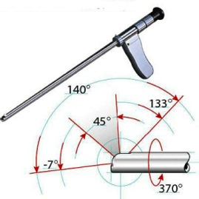
Swing Prism Endoscope

Swing prism endoscopes allow the operator to continuously adjust the viewing angle at the tip of the scope between -7 degrees back from full forward to + 133 degrees fully retrospective. This is almost unique as most allow a much narrower viewing angle.
The adjustable angle comes from the tip prism which is rotated via the eyepiece handle control, a focus control is also provided.
The advantage of this technology, allows a single scope solution where an application demands more than one viewing angle, thus reducing setup costs.

